REC GIVING DAY 2019 “HOW TO PROMOTE GIVING TUESDAY PACKET”
Become a REC CULTIVATOR!
Whatever you post, make it your own! Below is an outline of things to say/talk about with pictures you may choose from to include in your posts. Below you’ll find the REC mission statement, examples of Facebook statuses, REC program descriptions and a link to the description page. Please include the link to the description page in each post you make. Thank you for being a part of REC’s first #GivingTuesday. Let’s make raise support for the REC!
On Friday, November 29th, post an announcement about Giving Tuesday, explaining what it is and who they will be supporting this year (the REC!). They should also post the link to the giving page, which will include our story/narrative. On (Giving) Tuesday, December 3rd, volunteers will post again, with freedom to include some of the prompts mentioned above. The post should also include the link to the giving page.
Donation page link
- https://recworcester.kindful.com/?campaign=340052

REC logos & mission statement
The Regional Environmental Council fights for food justice in Worcester, making it their mission to build healthy, sustainable and just communities in Worcester and beyond. This is make possible through youth employment programs, school and community gardens, and community farmers markets.
(Just copy and paste/save the images and upload them as desired)

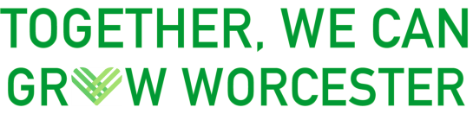

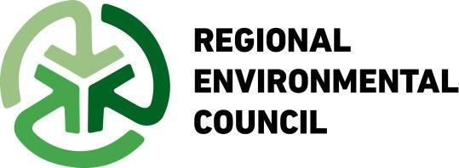

GIF’s!
Just open the link, right click on the GIF,
save it on your desktop, and upload it
as an image to Facebook!
Mobile Market GIF
Link: https://gph.is/g/E067pky

UGROW GIF
Link: https://gph.is/g/amAb8v5

YouthGROW GIF:
Link: https://gph.is/g/ZYx6bJ3

Facebook profile frame:
Can be found here: https://www.facebook.com/profilepicframes?query=rec%20giving%20tuesday&selected_overlay_id=953294625024214 (click this link to change your facebook frame on your facebook profile picture to promote giving Tuesday, and please tag us in your caption!)
Facebook status examples

- On Black Friday and Cyber Monday, you GET what you want. Why not GIVE what you want?

- "hey...it is the holiday. I really have everything I need, but can you help me supporting the ORG I support"

- Let’s come together to make a change in our community for the better.

- We ask you to join us in creating a new ritual for our annual calendar. #GivingTuesday is the opening day of the giving season; start yours by giving to the REC.

- Together, we can grow Worcester.

- With your help, the REC can continue to employ low-income youth and provide local, affordable and healthy food to underserved neighborhoods in Worcester.

- Help the REC reach their $5,000 goal this #GivingTuesday.
Laura McNaughton posts
- “A supporter of REC is offering to match contribution in honor of long time REC board member & Worcester activist Laura McNaughton. Laura was a tireless advocate and helped start the REC Earth Day Cleanups."

- “Laura McNaughton was a tireless advocate of making Worcester better. She helped start the Earth Day Cleanups. In her honor, on Giving Tuesday, a donor is challenging you all to give today support the REC.”

- "A supporter of REC is offering to match contribution in honor of long time REC board member & Worcester activist Laura McNaughton. Laura was a tireless advocate and helped start the REC Earth Day Cleanups."

- Help the REC reach their $5,000 goal this #GivingTuesday. Your contribution will go towards the purchase of a YouthGROW van to transport YouthGROWers to and from our farms.

- "Donate now and your gift will be matched up to $2,500!"

- "Your dollar goes farther with our matching gifts! Thanks to anonymous donors, your donation will be doubled until we reach $2,500!"

- "#doublethedonation this #givingtuesday by donation today! Each dollar you give will be DOUBLED thanks to an anonymous donor! Give today and your donation will be matched up to $2,500!"

- "Make your gift go even further! Donate today for your gift to be matched up to $2,500!"

- Program descriptions & pictures
  - UGROW
UGROW (Urban Garden Resources of Worcester) is a grassroots, city-wide community gardens network. UGROW is founded on the belief that together we can help create community food security by growing food in our own neighborhoods. UGROW poses an alternative to fossil-fueled, corporate agriculture and strengthens and beautifies our neighborhoods through promoting and supporting urban gardening. The UGROW network has over 60 community gardens throughout the city of Worcester involving more than 500 volunteer gardeners. Network gardens include neighborhood-based gardens, school gardens and urban farms.
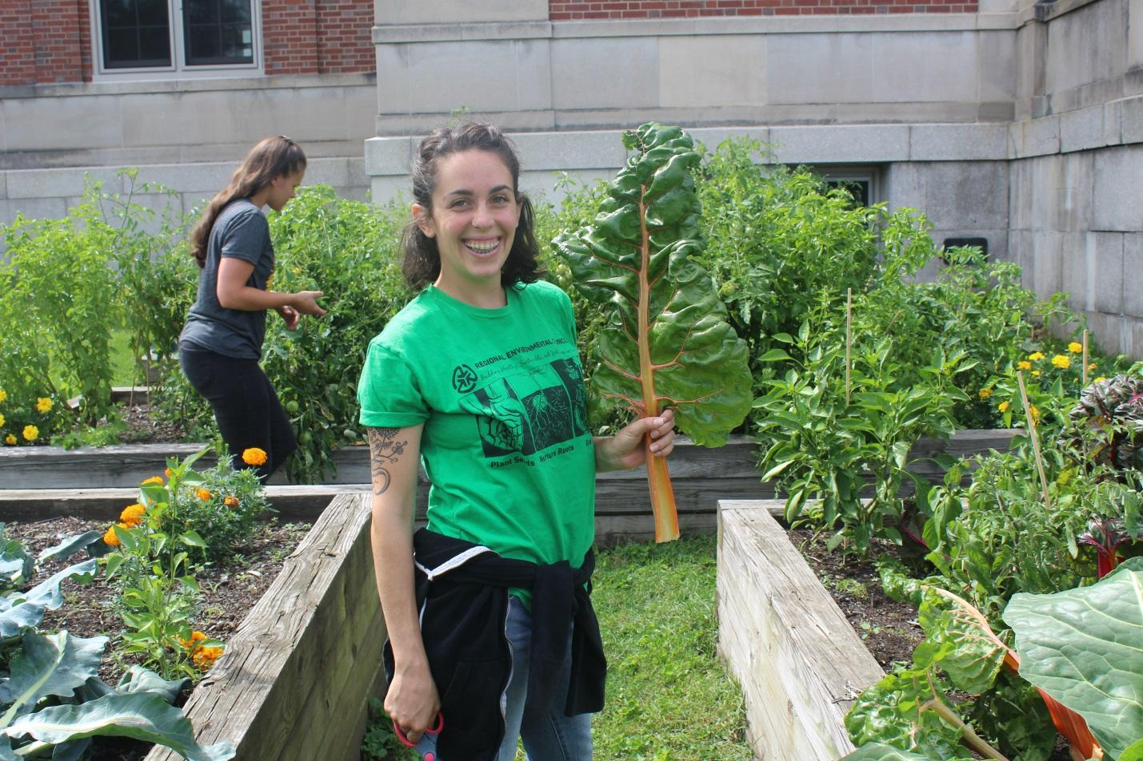

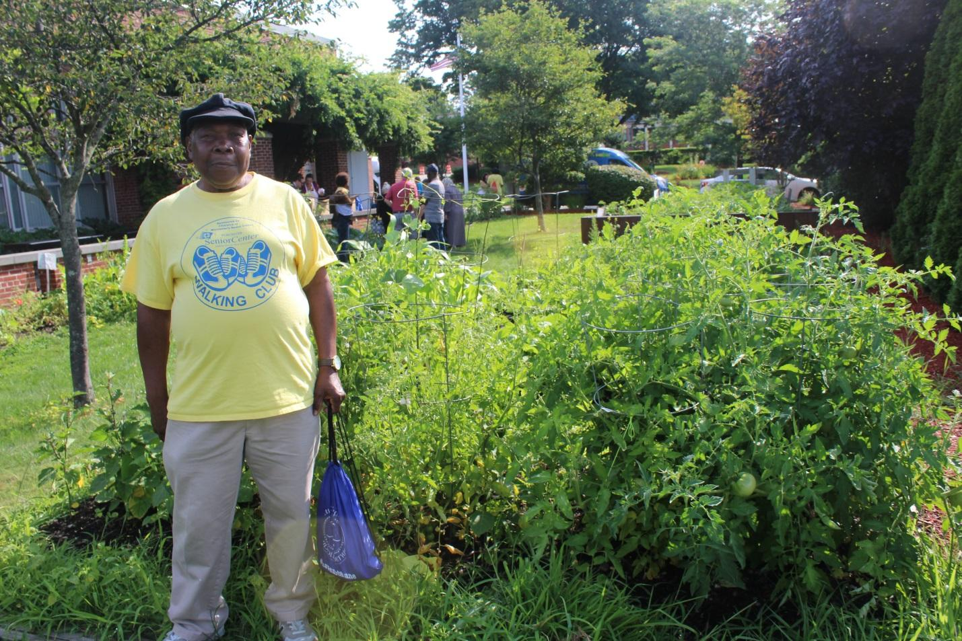

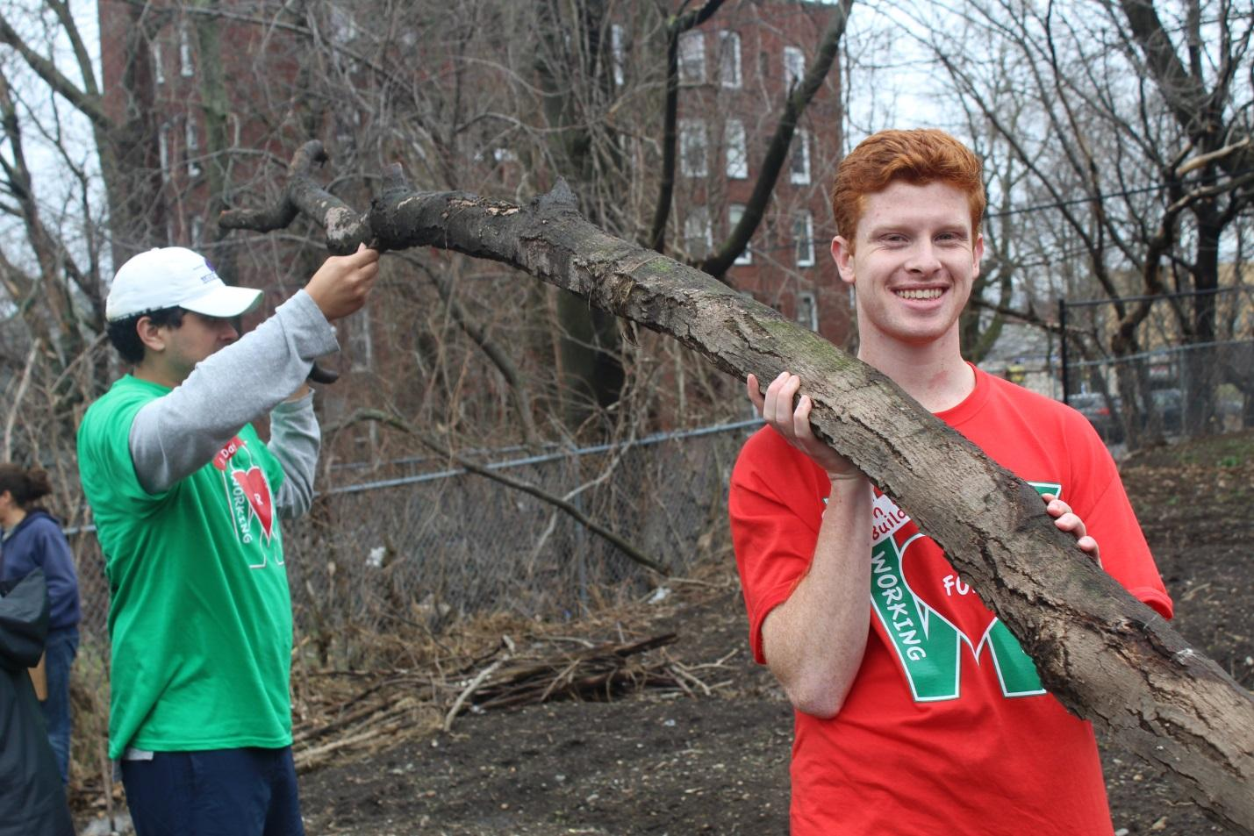

  - REC Community Farmers Markets

REC Community Farmers Markets consist of two standing farmers market as well as a mobile market, which drives around the city to 16 stops per week. The REC Mobile Market is the first successful mobile market in New England! REC standing farmers markets are open June-November, offering local food, live music, a children's playgroup and fun children's activities! All locations accept SNAP, WIC and Senior Coupons. By placing our Community Farmers Markets and Mobile Farmers Market stops in the most food-insecure neighborhoods in Worcester, we commit to creating access to healthy, affordable and local food to the families and individuals who need it most.

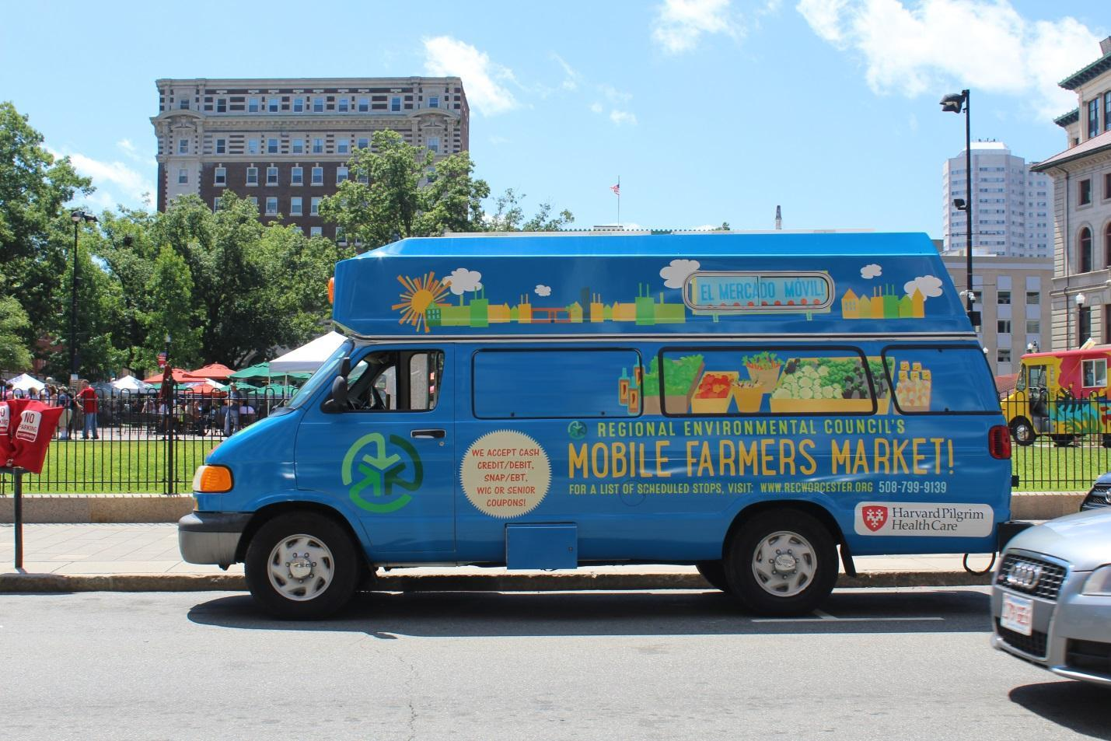

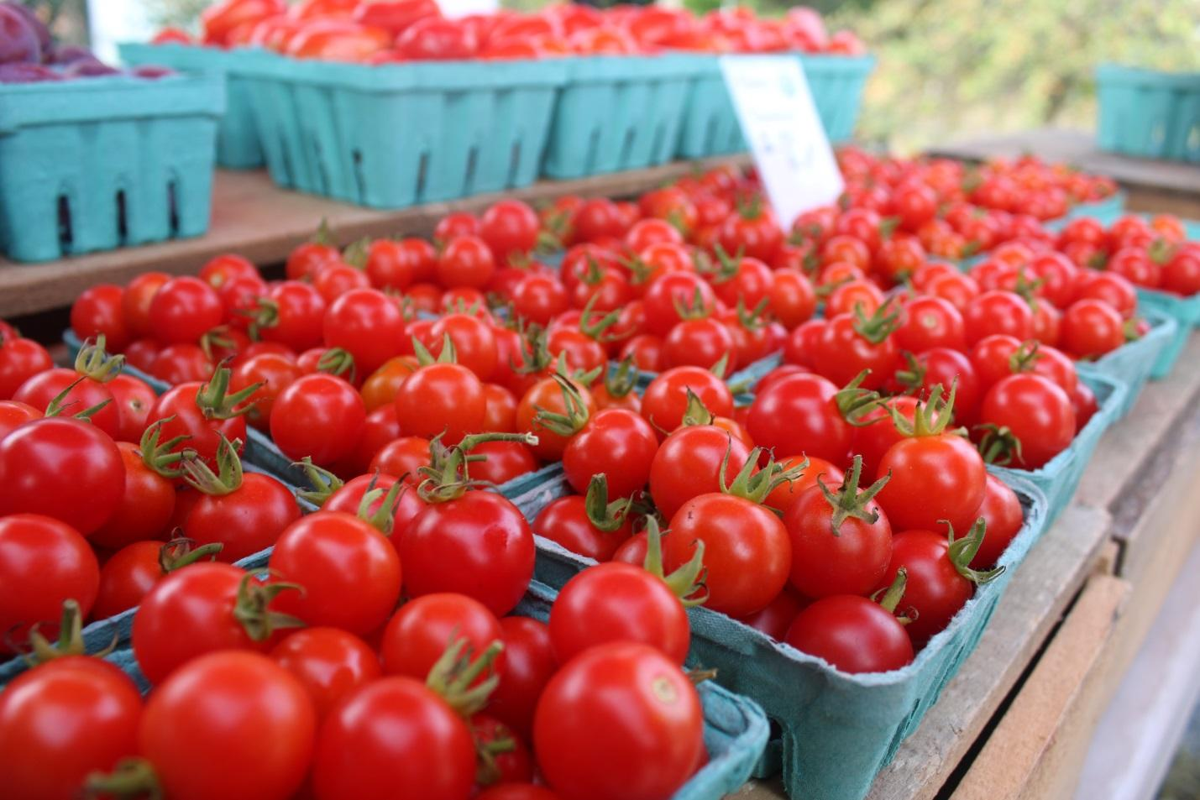

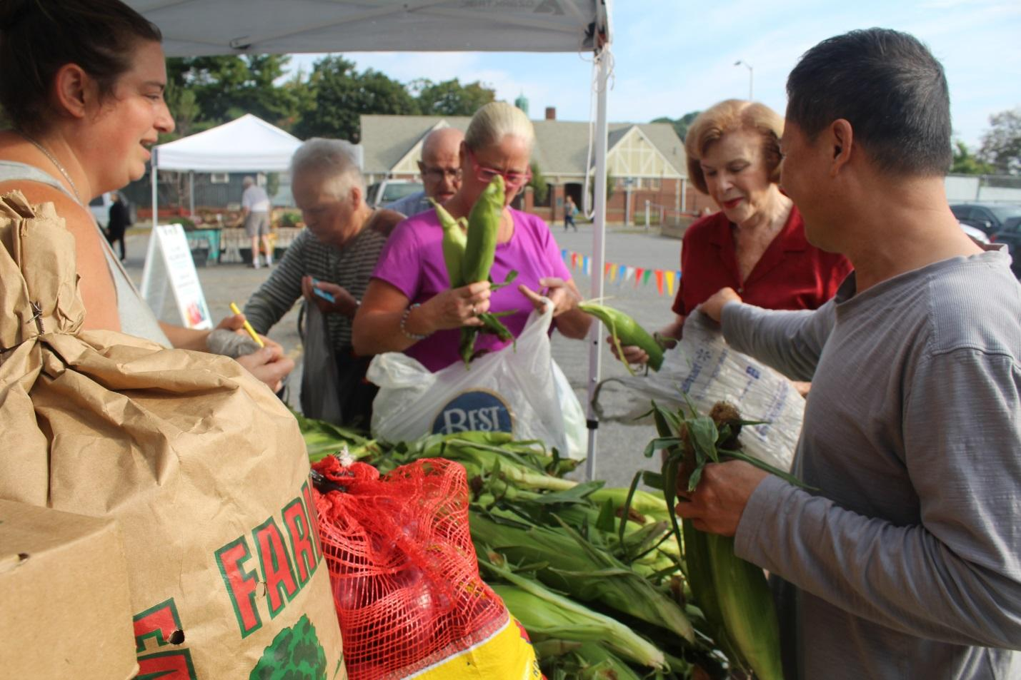

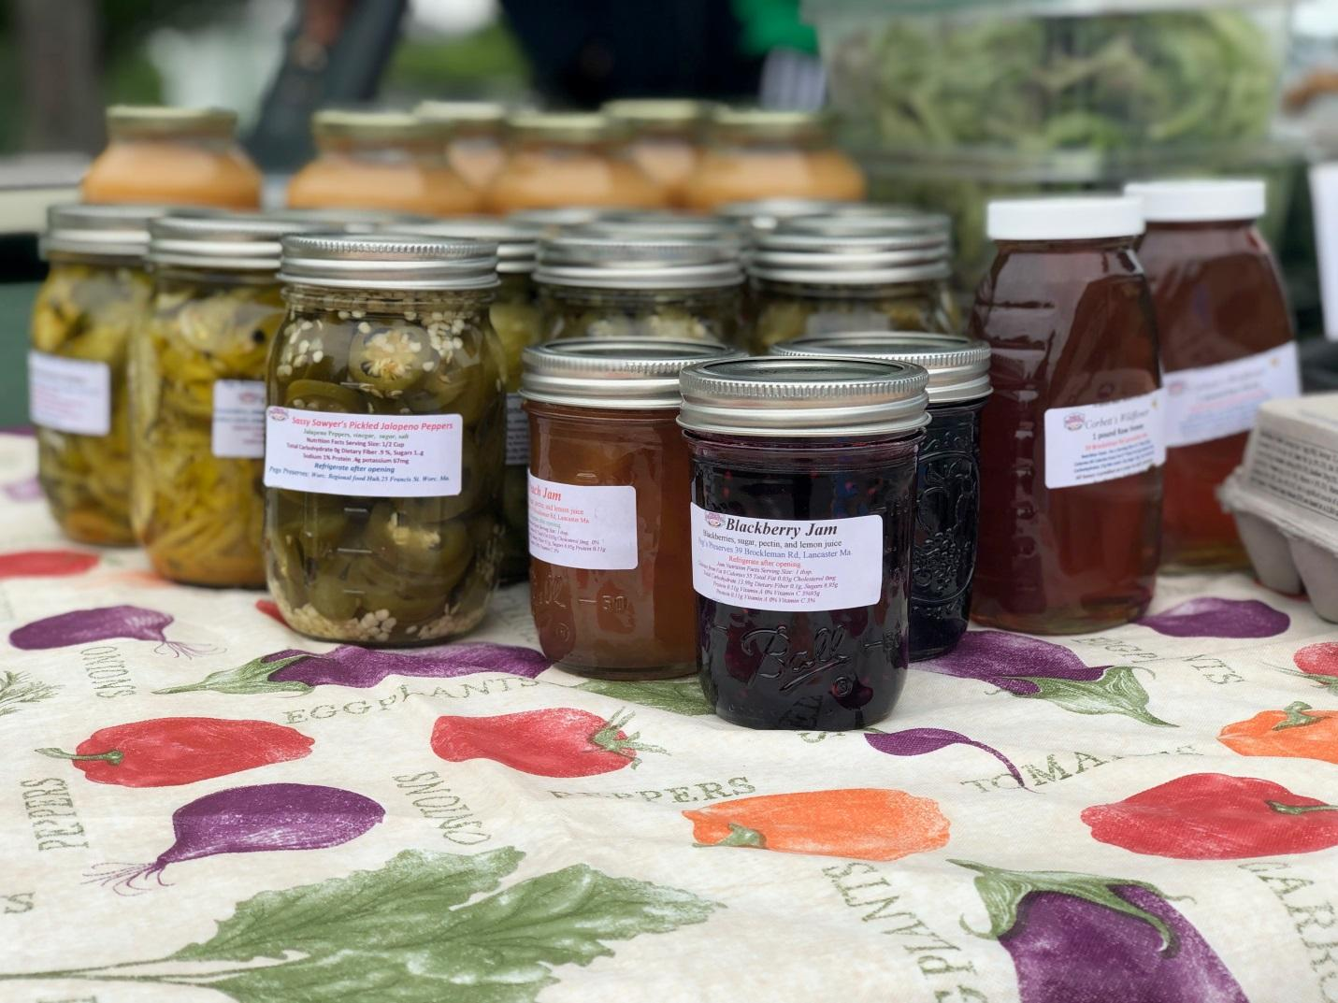

  - YouthGROW
YouthGROW is an urban agriculture-focused youth development and employment program for low-income teens. YouthGROW (Youth Growing Organics in Worcester) employs 32-40 low income high school teens (age 14-18) year-round who gain leadership and jobs skills as they maintain two urban organic farms. YouthGROWers complete a curriculum focused on Professional Development, Leadership Skills, Urban Agriculture, and Social Justice (PLUS,) through participation in the 8-week summer session, monthly workshops, internships, and community service.
